Cultural and Biochemical Characteristics of Acinetobacter baumannii isolated from Baghdad hospitals

Jinan M. AL-Saffar, Khitam K. AL-Masoudi, Ibrahim I. Shahad
Department of Biotechnology, College of Science, Baghdad University, Baghdad, Iraq.

Abstract
A total of 100 clinical sample from (urine, sputum, wound, burn and ear) were collected from patients in different hospitals of Baghdad during the period from December 2013 until May 2014. 15 isolates (15%) identified belong to Acinetobacter baumannii, swabs of wounds were represented in high percentage of A. baumannii isolates (40%) while percentage of other samples were variable. Susceptibility of 15 A.baumannii isolates were tested toward 16 different Antimicrobial agent, the results revealed all isolates were highly resistant to Cloxacillin, Oxacillin, Carbencillin, Methicillin and Cefotaxime in percentage 100% while 93.33% was resistant to Cefixime, Amoxicillin and Piperacillin, 87% to Imipenem, Meropenem, Trimethoprim+Sulfamethoxazole and Amoxicillin+Clavulani acid, whereas the isolates showed variable in resistant to other antimicrobial agents(ceftazidime, Amikacin, Ciprofloxacin, and Tetracyclin) in percentage (80,73,73 and 60)% respectively. The result of detection Beta-Lactamase from A. baumannii isolates by using rapid standard Iodometric assay and Acidometric assay showed that (11 and 10)isolates in percentage (73.33 and 66.66)% were β-lactamase producing respectively. Whereas 3(20%) isolates were able to produce extended spectrum β-lactamase (ESBL) using double disc synergy method.
Keyword: Antimicrobial agent, β- lactamase, Acinetobacter baumannii.

الخصائص الزرعية والكيموحيوية لبكتريا Acinetobacter baumannii المعزولة من مستشفيات بغداد
جنان محمد جواد الصفار, ختام خالص المسعودي, ابراهيم اسماعيل شهد
قسم التقنيات الاحيائية, كلية العلوم, جامعة بغداد, العراق

الخلاصة:
شملت الدراسة 100 عينه سريرية ومن مصادر مختلفة (الإدرار،القشع,مسحات الجروح,مسحات الحروق ومسحات الإذن) من مرضى مستشفيات مختلفة في بغداد, خلال الفترة الممتدة من كانون الأول 2013 حتى مايس 2014.,شخصت 15 عزله(15%) تعود إلى Acinetobacter baumannii مسحات الجروح مثلت اعلى نسبة حيث بلغت (40%) وتغايرت نسبة العزل في مصادر العينات الأخرى.اختبرت حساسية عزلات بكتريا Acinetobacter baumannii باتجاه 16 مضاد حيوي, أظهرت نتائج الاختبار أن جميع العزلات كانت مقاومة وبنسبة 100% للمضادات الحيوية (Cloxacillin and Oxacillin, Carbencillin, Methicillin , Cefotaxime) بينما كانت مقاومة وبنسبة 93.33 % للمضاداتCefixime and Amoxicillin, Piperacillin)) و87% ل (Imepenem, Meropenem, Trimethoprim+Sulfamethoxazole and Amoxicillin+Clavulanic acid) بينما تغايرت نسبة المقاومة للمضادات الحيوية الأخرى (ceftazidime and Amikacin, Ciprofloxacin, Tetracyclin) كانت تتراوح ما بين (80 and 73,73, 60) % على التوالي.تم اختبار قابلية العزلات على إنتاج أنزيمات ألبيتا لاكتا ميز باستخدام طريقة اليود القياسية السريعة وطريقة المقياس ألحامضي وأظهرت النتائج أن (10 and 11) عزله بنسبة (66.66 and 73.33)% على التوالي منتجة للأنزيمات. بينما (3) عزلات بنسبة 20% كانت منتجة لأنزيمات ألبيتا لاكتا ميز الواسعة الطيف باستخدام طريقة الأقراص المتآخمة.
1.Introduction
Acinetobacter baumannii is an aerobic, gram-negative, coccobacilli, non-lactose fermenting bacterium, which has recently emerged as an important opportunistic pathogen causing nosocomial infections, including pneumonia, septicemia, urinary tract infection and wound infections, and is also frequently involved in outbreaks[1]. The increasing clinical significance of Acinetobacter baumannii species is conditioned by its ability to survive in hospital environments, and its ability to instantly develop various drug resistance mechanisms acquired through antibiotic pressure[2].
Acinetobacter baumannii are frequently resistant to the drug families such as aminoglycosides, fluoroquinolones, and β-lactams (penicillins and cephalosporins) [3]. Carbapenems are usually the drug of choice in MDR, A. baumannii-caused infections[2]. however, reported the emergence of clinical A. baumannii strains that are resistant to imipenem[3]. Resistance rates to carbapenems among Acinetobacter spp. have increased dramatically in the last decade [4].
The most common mechanism of carbapenem resistance in Acinetobacter species is the production of carbapenem hydrolyzing class D β-lactamases (CHDLs) [5]. Other resistance mechanisms are attributed to reduced affinity of PBPs for Carbapenems, increased efflux of the β-lactam antibiotics, decreased permeability of the outer membrane or to a combination of reduced permeability and high-level production of a β-lactamase[6]. The aim of study was To determine the antimicrobial susceptibility patterns of A. baumannii isolates from different clinical sources and detection of β-Lactamase production by using different methods.
2. Materials and Methods
Sample collection
One hundred clinical specimens were collected during the period extending from first December 2013 untill May 2014,under aseptic condition by sterile containers ,it was comprising; urine, sputum,(wounds, burns, ear)swabs and from six Hospitals in Baghdad/Medical city. Samples were collected from different ages groups and genders.
Identification of A.baumannii
Culture characteristics: All the bacterial isolates were identified on MacConkey agar and blood agar as genaral laboratory media act as selective media in addition to VITEK 2 system.
Microscopically examination (Gram stain): All the bacterial isolates were examined their shape and arrangement cells under light microscope by using Gram stain.
Biochemical tests: which includes(oxidase, catalase, imvic) test to identification the bacterial isolate. Also the growth at 44ºC was employed to distinguished A. baumannii (which able to grow at 44ºC) from other Acinetobacter species which unable to grow at this temperature degree. in addition to VITEK 2 system which used for identification of Acinetobacter baumannii isolates.
Antimicrobial susceptibility Test
According to Kirby-Bauer method was dependent in Antimicrobials susceptibility test for 16 different Antimicrobial agent[7].
detection of β-Lactamase production
detect to β-Lactamase production were detected by two evaluated methods: Iodometric method[8] and Acidimetric method[9].while, detection of extended spectrum β-Lactamase (ESBL) production using Double disk synergy method[10].
3.Results and disscution
Identification of Acinetobacter baumannii
Fifteen isolates (15%) out of one hundred samples were identified as Acinetobacter baumannii according to cultural characteristics, microscopic examination, biochemical test, and the identification was confirmed by using Vitek2 system.
Culture characteristics: bacterial isolates were identified on their appearance on the media (figure 1). On MacConkey agar, the isolates appeared as non-lactose fermenter colonies while on blood agar colonies being non-hemolytic, domed, and muciod in both.

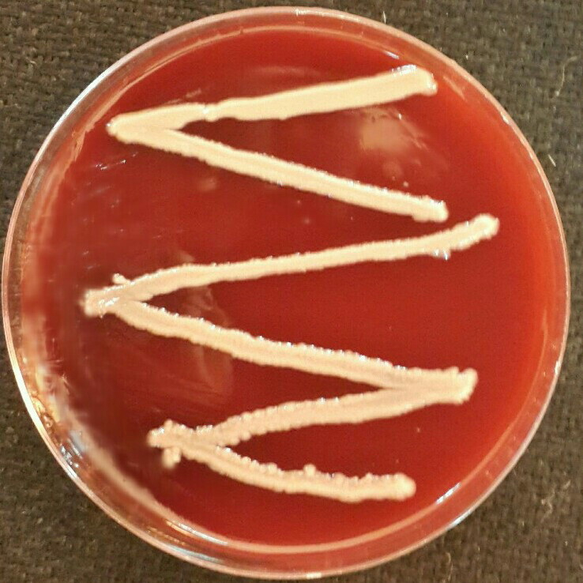
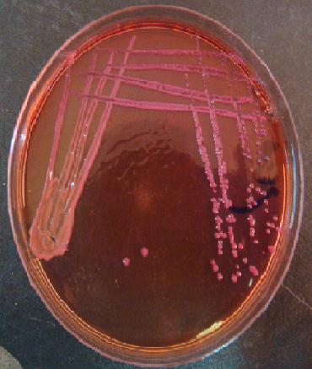
B
A

Figure 1: Acinetobacter baumannii colonies on Blood agar (A) and MacConkey agar (B), after 24 hours of incubation at 37ºC
Microscopic examination (Gram stain): All bacterial isolates were emergence under light microscopic as Gram negative coccobacilli (figure 2).
Figure (2): The microscopic examination of Acinetobacter baumannii cells under light microscope

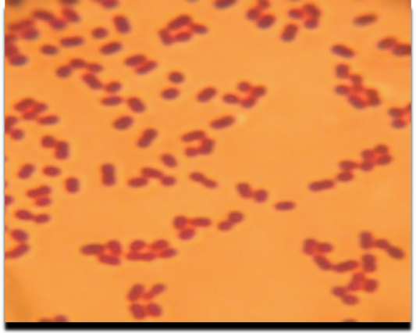

Biochemical tests: There were many biochemical test performed for identification the required bacterial isolates, as illustrate in table (1).

Table (1):The Biochemical tests for Acinetobacter baumannii.
NO. | Biochemical test | Result | NO. | Biochemical test | Result
1 | Catalase production | + | 6 | Growth at 44ºC | +
2 | Oxidase production | _ | 7 | Citrate utilization | +
3 | Motility test | _ | 8 | Methyl red test | _
4 | Lactose fermentation | _ | 9 | Voges -Proskauer test | _
5 | Indole production | _
+: positive result, - : negative result
At the species level, growth at 44ºC test was used to recognizing A. baumannii (which capable to grow at this temperature) from other Acinetobacter species which unable to grow at this temperature[11].All bacterial isolates was appearance positive result for this test. table (2) showed number of bacteria isolate.

Table (2): Number of bacteria isolate from different clinical sources
sample source | No. of A.baumannii isolates | Percentage %
Sputum | 2 | 13
Urine | 3 | 20
Burns | 4 | 27
Ear swab | _ | _
Wounds | 6 | 40
Total | 15 | 100

Antimicrobial Susceptibility test: The Susceptibility of 15 isolates of A. baumannii towards 16 different antibiotics were examined by using Kirby-Bauer method. The results showed different resistant patterns, which illustrated in figure (3).

Percentage of resistant %
Antimicrobial agents
Figure (3):The Susceptibility of A.baumannii isolates against antimicrobial agents

The obtaied results showed high level resistance of A. baumannii isolates to most antimicrobial agents used in this study, all isolates were resistant to penicillin group included Cloxacillin, Oxacillin, Carbencillin, Methicillin 100% while, Amoxicillin and Piperacillin were 93.33 %. In addition, A. baumannii isolates showed the high resistant against third generation of cephalosporin group including Cefotaxime, Cefixime and Ceftazidime in percentage (100,93.33 and 80)% respectively, the result agree with local study in Baghdad city who is found A.baumannii isolates were resistant 100% for Cefotaxime and 89.57% for Ceftazidime[12].
Present study showed high resistant to carbapenem 87% such as Imepenem and Meropenem, and 73% resistant to aminoglycoside such as Amikacin, Besides the resistant to (Amoxicillin+Clavulanic acid, Ciprofloxacin, Tetracyclin , Trimethoprim+sulfamethoxazole) in percentage (87, 73, 60 , 87)% respectively. The local study in Baghdad city found that various levels of resistant to several antimicrobial agents, that in agreement with results of the current study included carbencillin(100%), Cefotaxime(100%), Cefixime100%.while other results were disagreed with present study included Amikacin 50%, Ceftazidime 100%, Ciprofloxacin 63.63%, Imipenem 40%, Meropenem 50% and Tetracyclin 77.27%[13]. These differences in the results may be attributed to excessive use antimicrobial agents in the hospitals in the last few years. Probability, the differences in the results may be retained to increasing the spread of multidrug resistant mechanisms by genetic elements (mobile elements).
In previous study point out Acinetobacter spp. collected between 1994 and 1995 in five European countries from ICUs showed susceptibilities to Ceftazidime of 82%in Belgium, 19%in Portugal, 30%in France, 24%in Spain and 100%in Sweden, while, Susceptibility to imipenem was 88%in Belgium, 91%in France, 84%in Spain,95%in Portugal and 81%in Sweden^{(14,15)} .the susceptibility results by these previous study of Imipenem were compatible with the results of present study whereas Susceptibility of Ceftazidime was incompatibility due to geographic site and β-Lactamase production. Meanwhile, Spanish study has also documented significant levels of resistance, Ceftazidime resistance increased from 57.4% in1991 to 86.8%in 1996, while imipenem resistance increased from 1.3%to 80.0% either Ciprofloxacin resistant increased from 54.4% to 90.4% also Amikacin 21% to 83.7%, Ceftazidime 57.4% to 86.8% and Trimethoprim-sulfamethxazole 41.1% to 88.9%[16].
On the other hand, A. baumannii isolates from patients in 37 European hospitals between 1997–2000, showed the greatest clinically useful activity. Susceptibility of A. baumannii to meropenem very high (97–100%) in all countries except Italy (70%), Unite Kingdom(UK) (77%) and Turkey (66%). A similar pattern was observed for imipenem (93–100%), except in Italy (78%), Turkey (62%) and the UK (78%)[17]. this results were agreement with results of the present study. The resistance of A. baumannii to antimicrobial agents is mediated by all of the major resistance mechanisms known to occur in bacteria including degradation enzymes against ß-lactams, modification enzymes against aminoglycosides, altered binding sites for Quinolones, and a variety of efflux mechanisms and changes in outer membrane proteins have been reported [1].
detection of β-Lactamase production
Iodometric method: Of all isolates 15 were undergoes to this test,the result revealed that 11(73.33%) isolates (Ab3,Ab4,Ab5,Ab6, Ab7,Ab8,Ab10,Ab11,Ab12,Ab14 and Ab15) gave positive result during (1-10)min, this point out ability of the isolates for β-lactamase production, 4(36.36%) isolates (Ab3,Ab5,Ab7 and Ab10) from 11 isolate gave a positive reaction in 1 min, While 3 (27.27%)(Ab4,Ab14 and Ab15) isolates required 5min and the remaining isolates (36.36%) (Ab6,Ab8,Ab11 and Ab12) gave positive reaction after 10 min. 4isolates (26.66%) (Ab1,Ab2,Ab9 and Ab13) gave negative result. the difference in the time of reaction results depended on the enzyme concentration inside bacteria, in addition, the temperature and pH played an important role in production of enzyme[18].The previous study confirmed the efficiency of this method to detect β-Lactamase production in Aeromonas spp. and demonstrated that all isolates gave positive result[19]. However, the technique has several useful characteristics, the reaction is completed within10 min and the materials are readily available in most microbiology laboratories, In addition, the penicillin powder is inexpensive and stable in dry form for at least 6 months or more [20].
In local study mentions that 45.6% of A.baumannii isolate was positive reaction to Iodometric assay but 54.4% of isolates given negative result[20], the results are away from the present study result. β-Lactamase production is consider the main mechanism for bacterial resistance to β-lactam antibiotics. The level of resistance is closely related to the β-lactamase activity, and the substrate specificity of the β-lactamase[14]. Study demonstrated that ability of A.baumannii to β-Lactamases production that degradation β-lactam ring in penicillins and cephalosporins[21].
Acidometric method: Fifteen isolate of A. baumannii were examined, 10 (66.66%) isolates (Ab3,Ab4,Ab5,Ab6,Ab7,Ab8,Ab10,Ab11,Ab14 andAb 15) were found to be positive for β-lactamase production during 5 min, whereas 5 isolates (33.33%) (Ab1,Ab2,Ab9,Ab12andAb13) were demonstrated a negative result. Previous study reported that total of 74 different clinical isolates of Branhamella catarrhalis were examined for their ability to produce beta-lactamase,they demonstrated that 58 isolates were positive for this test[22]. past study done found that among 24 isolates Haemophilus influenzae collected from Unit Kingdom,only nine isolates gave positive result[23]. The study in which proved efficiency of this method during detection for β- Lactamase production from staphylococcus aureus,400 clinical isolates were collected, 52 % of them gave positive result[24].
Detection of extended spectrum β-Lactamase production using Double disk synergy method: The results for detection of extended spectrum beta-lactamase producing from fifteen isolates of A.baumannii showed three isolates 20% (Ab3,Ab5 and Ab11) were able for production extended spectrum beta-lactamase whereas twelve isolates (80%) gave negative result and this was agree with other study in Iraq who demonstrated three isolates (13.6%) producing extended spectrum beta-lactamase out of 22 isolates[13].
The previous study in Japan reported three isolates of A.baumannii gave positive result by double disk synergy test[25]. Other study in Bolivia reported unability the isolates of A.baumannii to production extended-spectrum β-lactamase, This suggests that resistance to antimicrobial agent could be due to other mechanisms, such as the expression of chromosomal ADC β-lactamase, reduced membrane permeability caused by a decrease in expression of porin genes and an increase in the efficiency of efflux pumps[26]. In this regard, decrease sensitivity for this test can be explained by the presence both ESBL & inducible AmpC enzymes in the isolates; Clavulanic acid which was used for ESBL detection and act as inducers of high level AmpC production and it led to resistance antimicrobial agents,furthermore, if ESBL was present, it would not be detected and resulted in false negative test [27].

Reference:
1-Fishbain, J. and Peleg, A.Y.(2010). Treatment of Acinetobacter Infections, Clinical Infectious Diseases 51(1):79–84.
2-Netsvyetayeva, I.; Sikora, M.; Golas, M.; Swoboda-Kopec, E.; Walter de Walthoffen, S.; Dembicka, O.; Fraczek, M.; Mlynarczyk, A.; Pacholczyk, .M; Chmura, A. and Mlynarczyk, G.(2011). Acinetobacter baumannii Multidrug-Resistant Strain Occurrence in Liver Recipients With Reference to Other High-Risk Groups. Transplantation Proceedings.43: 3116 –3120.
3-Siroy, A.; Molle, V.; Lemaitre-Guillier, C.; Vallenet, D.; Pestel-Caron, M.; Cozzone, A.J.; Jouenne, T. and De, E.(2005). Channel Formation by CarO, the Carbapenem Resistance-Associated Outer Membrane Protein of Acinetobacter baumannii. Antimicrobial Agents and Chemotherapy. 49(12):4883-4876.
4- Montealegre, M.C.; Maya, J.J.; Correa, A.; Espinal, P. ; Maria, F.; Mojica, M.F.; Ruiz, S.J.; Rosso, F.; Vila, J.; Quinn, J.P. and Villegas, M.V.(2012). First Identification of OXA-72 Carbapenemase from Acinetobacter pittiiin Colombia. Antimicrobial Agents and Chemotherapy. 56(7): 3996 –3998.
5-Lee,Y.; Kuo,S.;Chiang, M.; Yang, S.; Chen, C.; Chen, T. and Fung, C.(2011). Emergence of Carbapenem-Resistant Non-baumannii Species of Acinetobacter Harboring a bla _{OXA-51-Like} Gene That Is Intrinsic to A. baumannii. Antimicrobial Agents and Chemotherapy. 56(2): 1124 –1127.
6- Lopes, B.S.; Evans, B.A. and Amyes, S.G.B.(2011). Disruption of the bla_{OXA-51-like}gene by ISAba16 and activation of the_{blaOXA-58}gene leading to carbapenem resistance in Acinetobacter baumannii Ab244. Journal of Antimicrobial Chemotherapy. 67:59–63.
7- CLSI, (Clinical and Laboratory Standards Institute) (2012). Performance standard for antimicrobial susceptibility testing; Approved Standard-Eleventh Edition. M02-S11. 32(1).
8- Collee, J.; Fraser, A.; Marmion, B. and Simons, A. (1996). Mackie and McCartney’s Practical Medical Microbiology. (14thed.). Churchill livingistone, U.S.A., P:561.
9-Livermore, D.M. and Brown, D.F.J.(2001). Detection ofβ-lactamase mediatedresistance. JournalAntimicrobialChemotherapy.48 (1): 59-64.
10-Jarlier,V.; Nicola,M.; Fournier,G. and Philippon, A. (1988). Extended broad-spectrum β-lactamases conferring transferable resistance to newer β-lactam agents in Enterobacteriaceae: hospital prevalence and susceptibility patterns. Reviews of infectious diseases. 10: 867–878.
11- Peymani, A.; Farajnia, S.; Nahaei, M. R.; Sohrabi, N.; Abbasi, L.; Ansarin, K. and Azhari, F.(2012). Prevalence of Class 1 Integron Among Multidrug Resistant Acinetobacter baumannii in Tabriz, Northwest of Iran. Polish Journal Microbiology. 61(1): 57–60.
12- AL-Saleem, N.H.H.(2013). Genotyping relatedness of Acinetobacter baumannii isolated from Medical City/Baghdad. PH.D. dissertation. Biology department.College of Sciences. Baghdad University.
13- Al-Mash’hadani, E. I. J. (2010). Study The activity of Bacteriocin produced from Lactobacillus plantarum on virulence factors of Acinetobacter baumannii. Msc. thesis. Biology department. College of Science. ALMustansiriyah University.
14- Glupczynski, Y.; Delmee, M.; Goossens, H. and Struelens, M.A.
( 1998). multicentre survey of antimicrobial resistance in gram negative isolates from Belgian intensive care units in 1994–1995. Belgian Multicenter ICU Study Group.Acta Clinica Belgica. (53): 28–38.
15- Hanberger, H.; Garcia-Rodriguez, J.A.; Gobernado, M.; Goossens, H.; Nilsson, L.E. and Struelens, M.J.( 1999). Antibiotic susceptibility among aerobic gram-negative bacilli in intensive care units in 5 European countries. French and Portuguese ICU Study Groups. Journal of the American Medical Association. (281): 67–71.
16- Ruiz, J.; Nunez, M.L.; Perez, J.; Simarro, E.; Martinez-Campos, L.and Gomez, J.( 1999). Evolution of resistance among clinical isolates of Acinetobacter over a 6-year period. European journal of clinical microbiology & infectious diseases.(18): 292–295.
17-Turner,P.J.andGreenhalgh ,J.M.( 2003).The activity of meropenem and comparators against Acinetobacter strains isolated from European hospitals, 1997–2000.Clinical Microbiology Infection.(9): 563–567.
18- Foley, J.M. and Perret, G.J.(1962).Screening bacterial colonies for penicillinase production.Natur,1995(4836):287-288.
19- Al-Khalidi, R.A.A.H.(2006). Bacteriological and genetic study on Aeromonas spp. B-lactamase Producers.M.sc thesis.Department of Biotechnology. college of science. Baghdad university.
20- AL-Muhanna, A.S.J.(2006). A Molecular and Genetic Study of Virulence Factors of Acinetobacter isolated from different infections. PH.D. dissertation. Biology department.College of Sciences. ALMustansiriyah University.
21- Husni, R.,H. ; Goldstein L.S.; Arroliga A.C. ; Hall G.S.; Fatica,R.N.C.; Stoller J.K. and Gordan, S. M.(1999). Risk facters for an outbreak of multi-drugs resistant Acinetibacter nosocomial pneumonia among intubated patients .Chest.115 :1378-1382.
22-Doern, G.V. and Tubert ,T.A.(1987). Detection of beta-lactamase activity among clinical isolates of Branhamella catarrhalis with six different beta-lactamase assays. Journal Clinical Microbiology.25 ( 8): 1380-1383.
23- Skinner, A. and Wise, R. (1977). A comparison of three rapid methods for the detection of β-lactamase activity in Haemophilus influenza. Journal of Clinical Pathology. 30: 1030-1032.
24- Samant, S.A. and Pai, C.G.(2012). Comparative evaluation of β lactamase detection methods in Staphylococci. International Journal of Research in Pharmaceutical and Biomedical Sciences.3(4):1580-1588.
25- Nagano, N.; Nagano, Y.;Cordevant, C. ; Shibata, N. and Arakawa, Y. (2004). Nosocomial Transmission of CTX-M-2 β -Lactamase-Producing Acinetobacter baumannii in a Neurosurgery Ward. Journal Clinical Microbiology. 42 (9): 3978-3984.
26- Sevillano, E.; Fernandez, E.; Bustamante, Z.; Zabalaga, S.; Rosales, I.; Umaran, A. and Gallego, L.(2012). Emergence and clonal dissemination of carbapenem-hydrolysing OXA-58-producing Acinetobacter baumannii isolates in Bolivia, Journal of Medical Microbiology. 61:80–84.
27- Dhara, M.; Disha,P.; Sachin,P.; Manisha1,J.; Seema,B. and , Vegad M. M.(2012). Comparison of various methods for the detection of extended spectrum beta- lactamase in Klebsiella pneumoniae isolated from neonatal intensive care unit. National Journal of Medical Research.2(3):348-353.

